Edison Henao Carvajal, Isabel Llanos Chaparro, Pilar Sanchez-Beltran

Universidad Nacional de Colombia

# González Zuleta, Guillermo (Bogotá, 1916?-1995)

A structural engineer and designer, González Zuleta was engaged in pioneering architectural and engineering works in Colombia over a period of more than fifty years. His interest in exploring new forms and techniques was a keystone in the development of concrete works of infrastructure nationwide. Having begun his studies in industrial engineering at the Universidad Nacional de Chile, two years later he returned to Bogotá where he went on to achieve a Bachelor’s degree in civil engineering from the Universidad Nacional de Colombia (1940); in 1986 the same university conferred on him a doctorate *honoris causa*.

Guillermo González Zuleta was a son of the engineer Fabio González Taver, winner of the Ponce de Leon award and a scholar of the Universidad Nacional de Colombia, and a grandson of Juan Nepomuceno González Vasquez,[1] an engineer who studied at the École Centrale du Paris and who was known for having built a bridge across the Tiber (Rome). He went on to design the first railroads in Colombia, and was also a founder partner of the Colombian Society of Engineers. González Zuleta thus continued a family tradition.

During the 1940s and 1950s González Zuleta worked in the public sector, as director of Public Works in Ibague and later as principal of the department of [structural] calculation of the Ministry of Public Works, and also as deputy director of National Buildings. As a scholar, he was a professor of architecture and engineering at the Universidad Nacional de Colombia and Universidad de los Andes. In his private practice, Gonzales Zuleta was involved in works nationwide, designing, consulting on, and building such structures as stadiums, coliseums, churches, transport stations, water treatment plants, and monasteries.

During his professional career, he promoted the integration between architecture and engineering, and challenged traditional structures. He was a pioneer in the early 1940s in the development of concrete shells,[2] hyperbolic paraboloids, sequenced vaults,[3] and the use of preforce concrete.[4]

Gonzales Zuleta received the national award of engineering three times: in 1947 for the baseball stadium in Cartagena; in 1967 for the structural design of Manaure harbour; and in 1974 for the El Campín Coliseum in Bogotá. In 1991, the Society of Colombian Architects honoured him with the ‘José Gómez Pinzón’ lifetime achievement award.

## Selected Works

1946-47 Baseball stadium in Cartagena, with Jorge Gaitán and Edgar Burbano, and the firm Ortega-Solano.

1947-50 Market at Girardot, with Leopoldo Rother.

1950-51 Bus station in Bogotá, with the firm Ortega-Solano.

1954-56 Gimnasio Moderno school’s chapel in Bogotá, with Juvenal Moya.

1955 Volkswagen showroom and plant in Bogotá, with Bruno Violi.

1955-56 Techo hippodrome in Bogotá, with Álvaro Hermida.

1956-59 Olympic Villa in Cartagena, with Carlos Hernández, Germán Samper, Eduardo Pombo, and the firms Ricaurte-Carrizosa-Prieto and Obregón-Valenzuela.

## References and further reading

Academia de Historia de Cundinamarca. (s.d.). Juan Nepomuceno González Vásquez Retrieved 02/09/2013

Arango, J., & Martínez, C. (1951). *Arquitectura en Colombia : arquitectura colonial 1538-1810, arquitectura contemporánea en cinco años 1946-1951*. Bogotá: Proa.

Jaramillo Jiménez, J. O. Ingeniería Estructural I, Universidad Nacional de Colombia Retrieved 02/09/2013

Vargas Caicedo, H. (2009). El desarrollo de la edificación en concreto armado en Colombia: El caso de los pioneros Doménico Parma y Guillermo González Zuleta (1945-1985). . *Revista DeArq, 4*, 64-75.

## Visual Material

1946-47 Baseball stadium in Cartagena, with Jorge Gaitán and Edgar Burbano, and the firm Ortega-Solano.

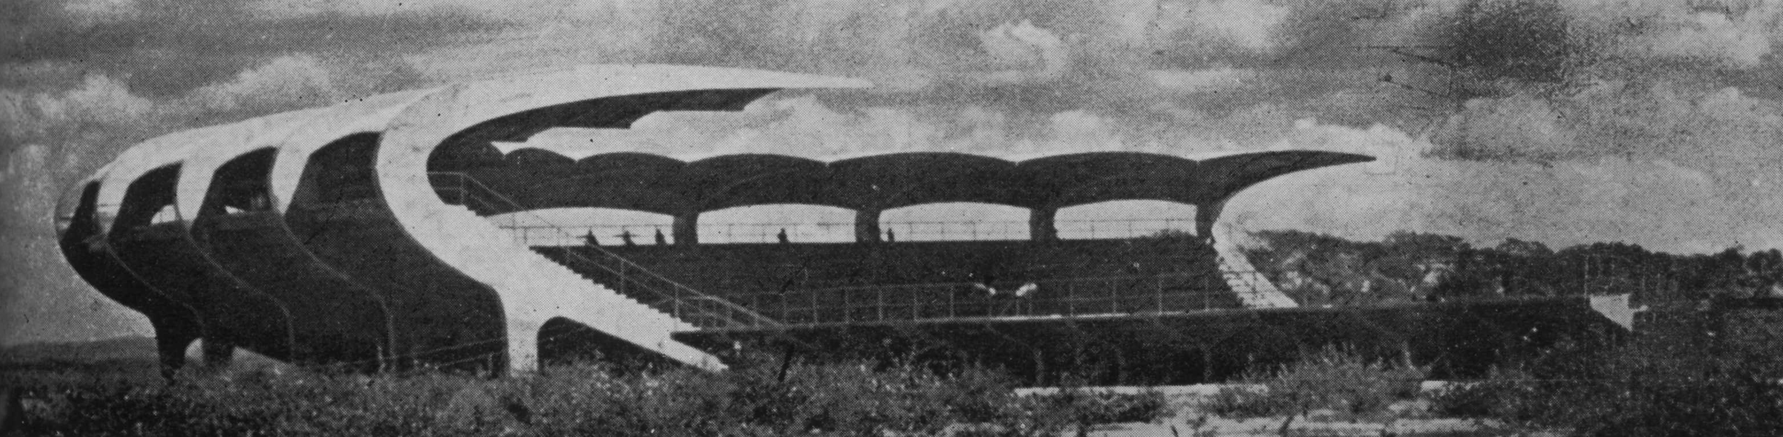

1947-50 Market at Girardot, with Leopoldo Rother.

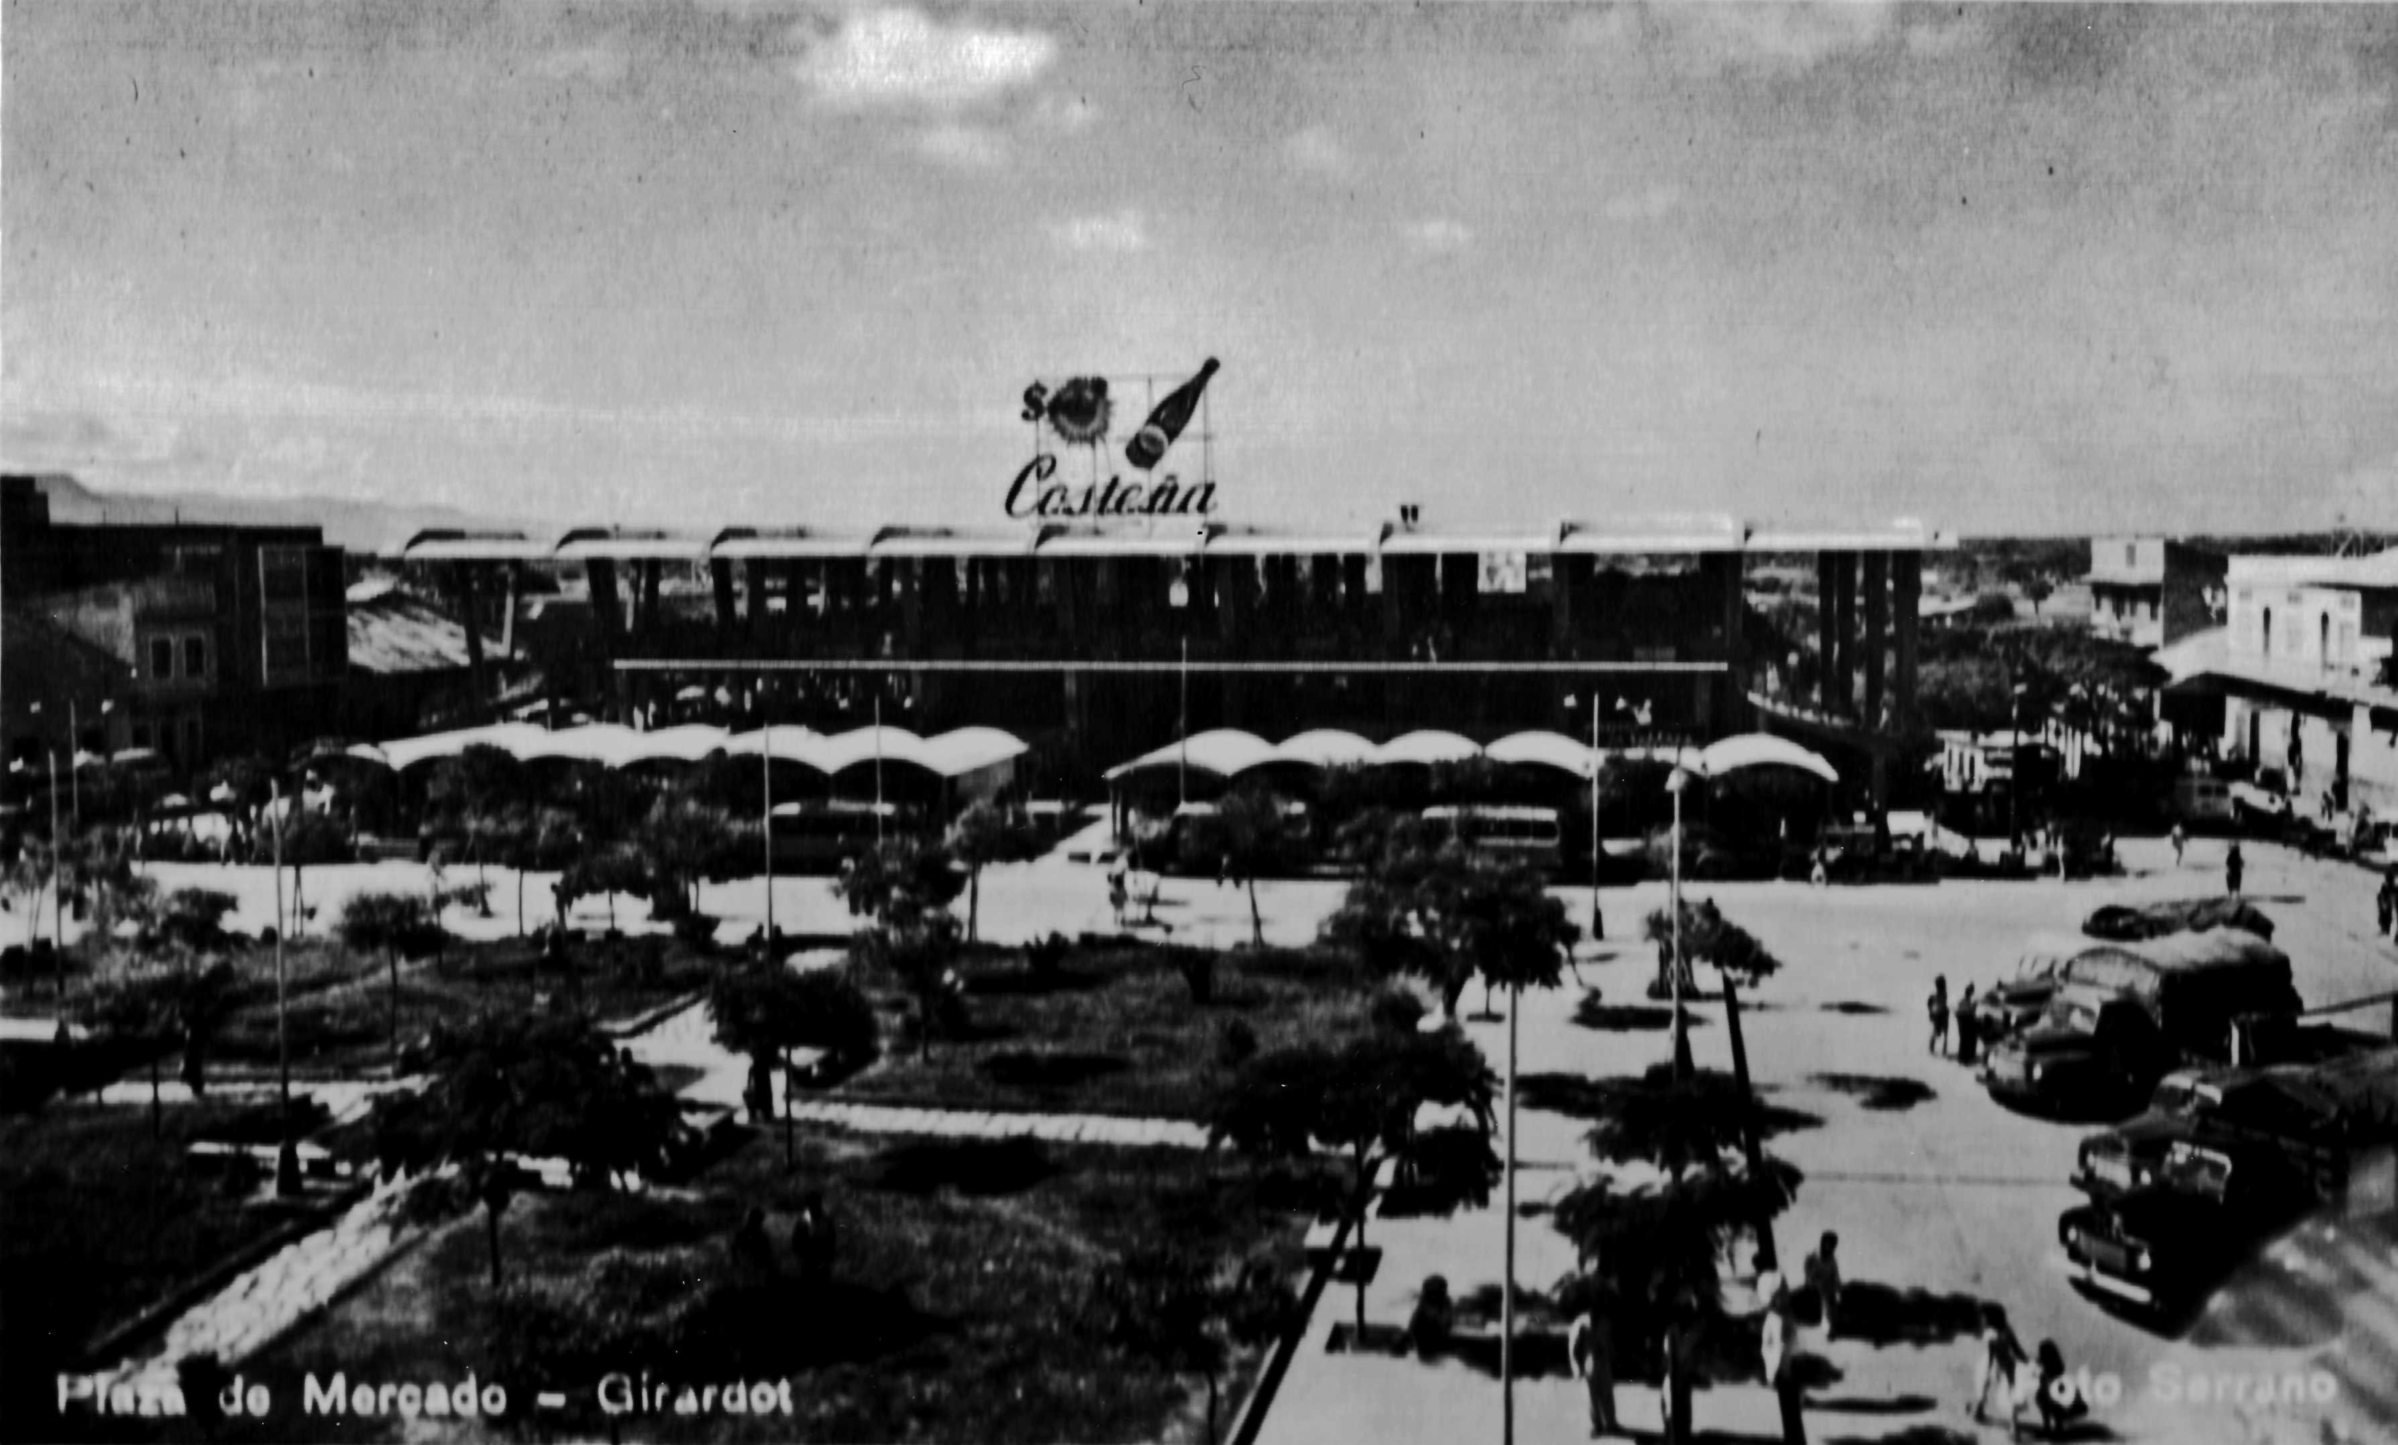

1950-51 Bus station in Bogotá, with the firm Ortega-Solano.

1954-56 Gimnasio Moderno school’s church in Bogotá, with Juvenal Moya.

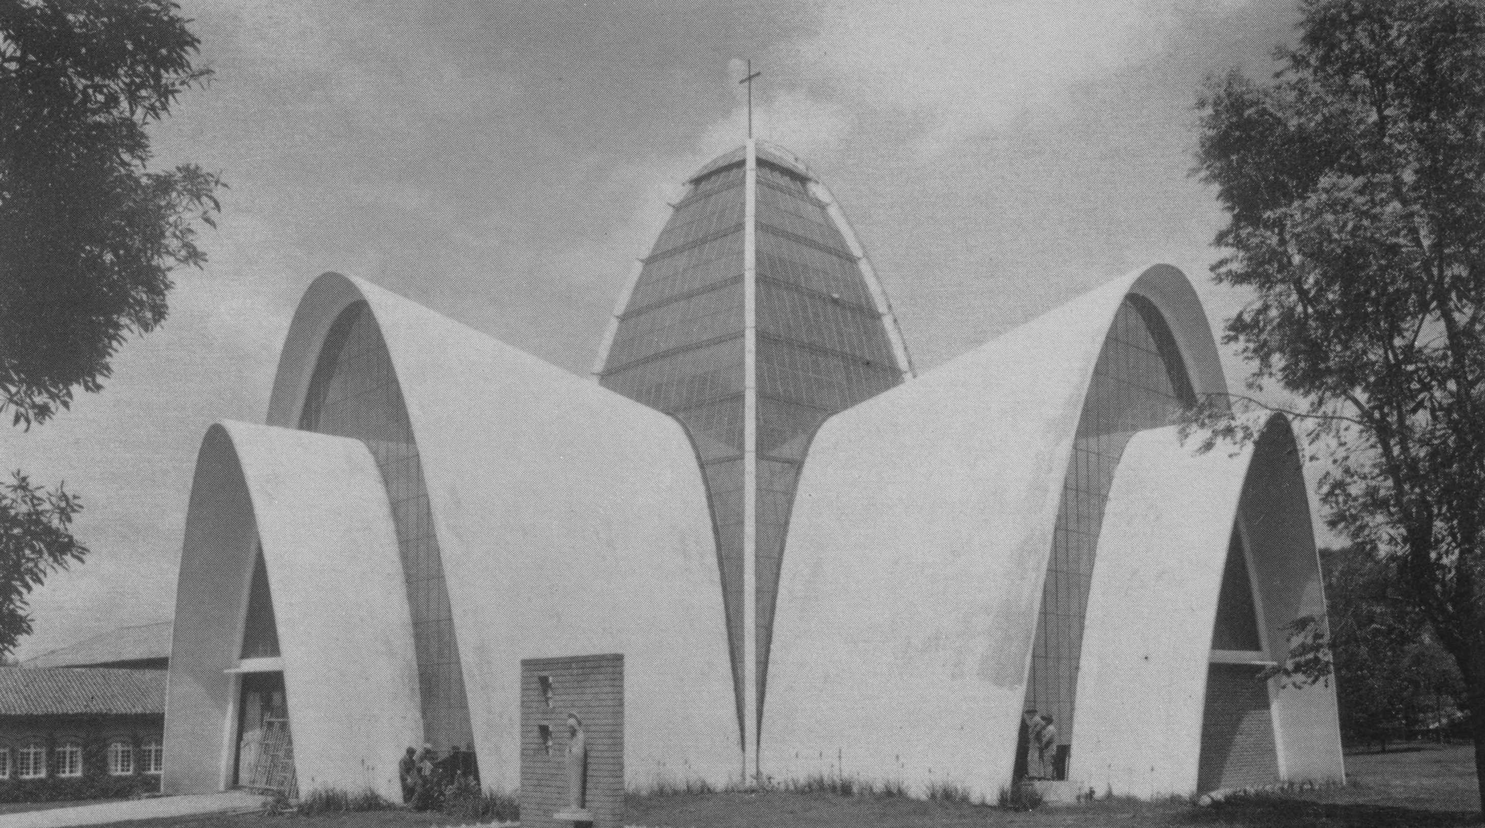

1955 Volkswagen showroom and plant in Bogotá, with Bruno Violi.

1955-56 Techo hippodrome in Bogotá, with Álvaro Hermida.

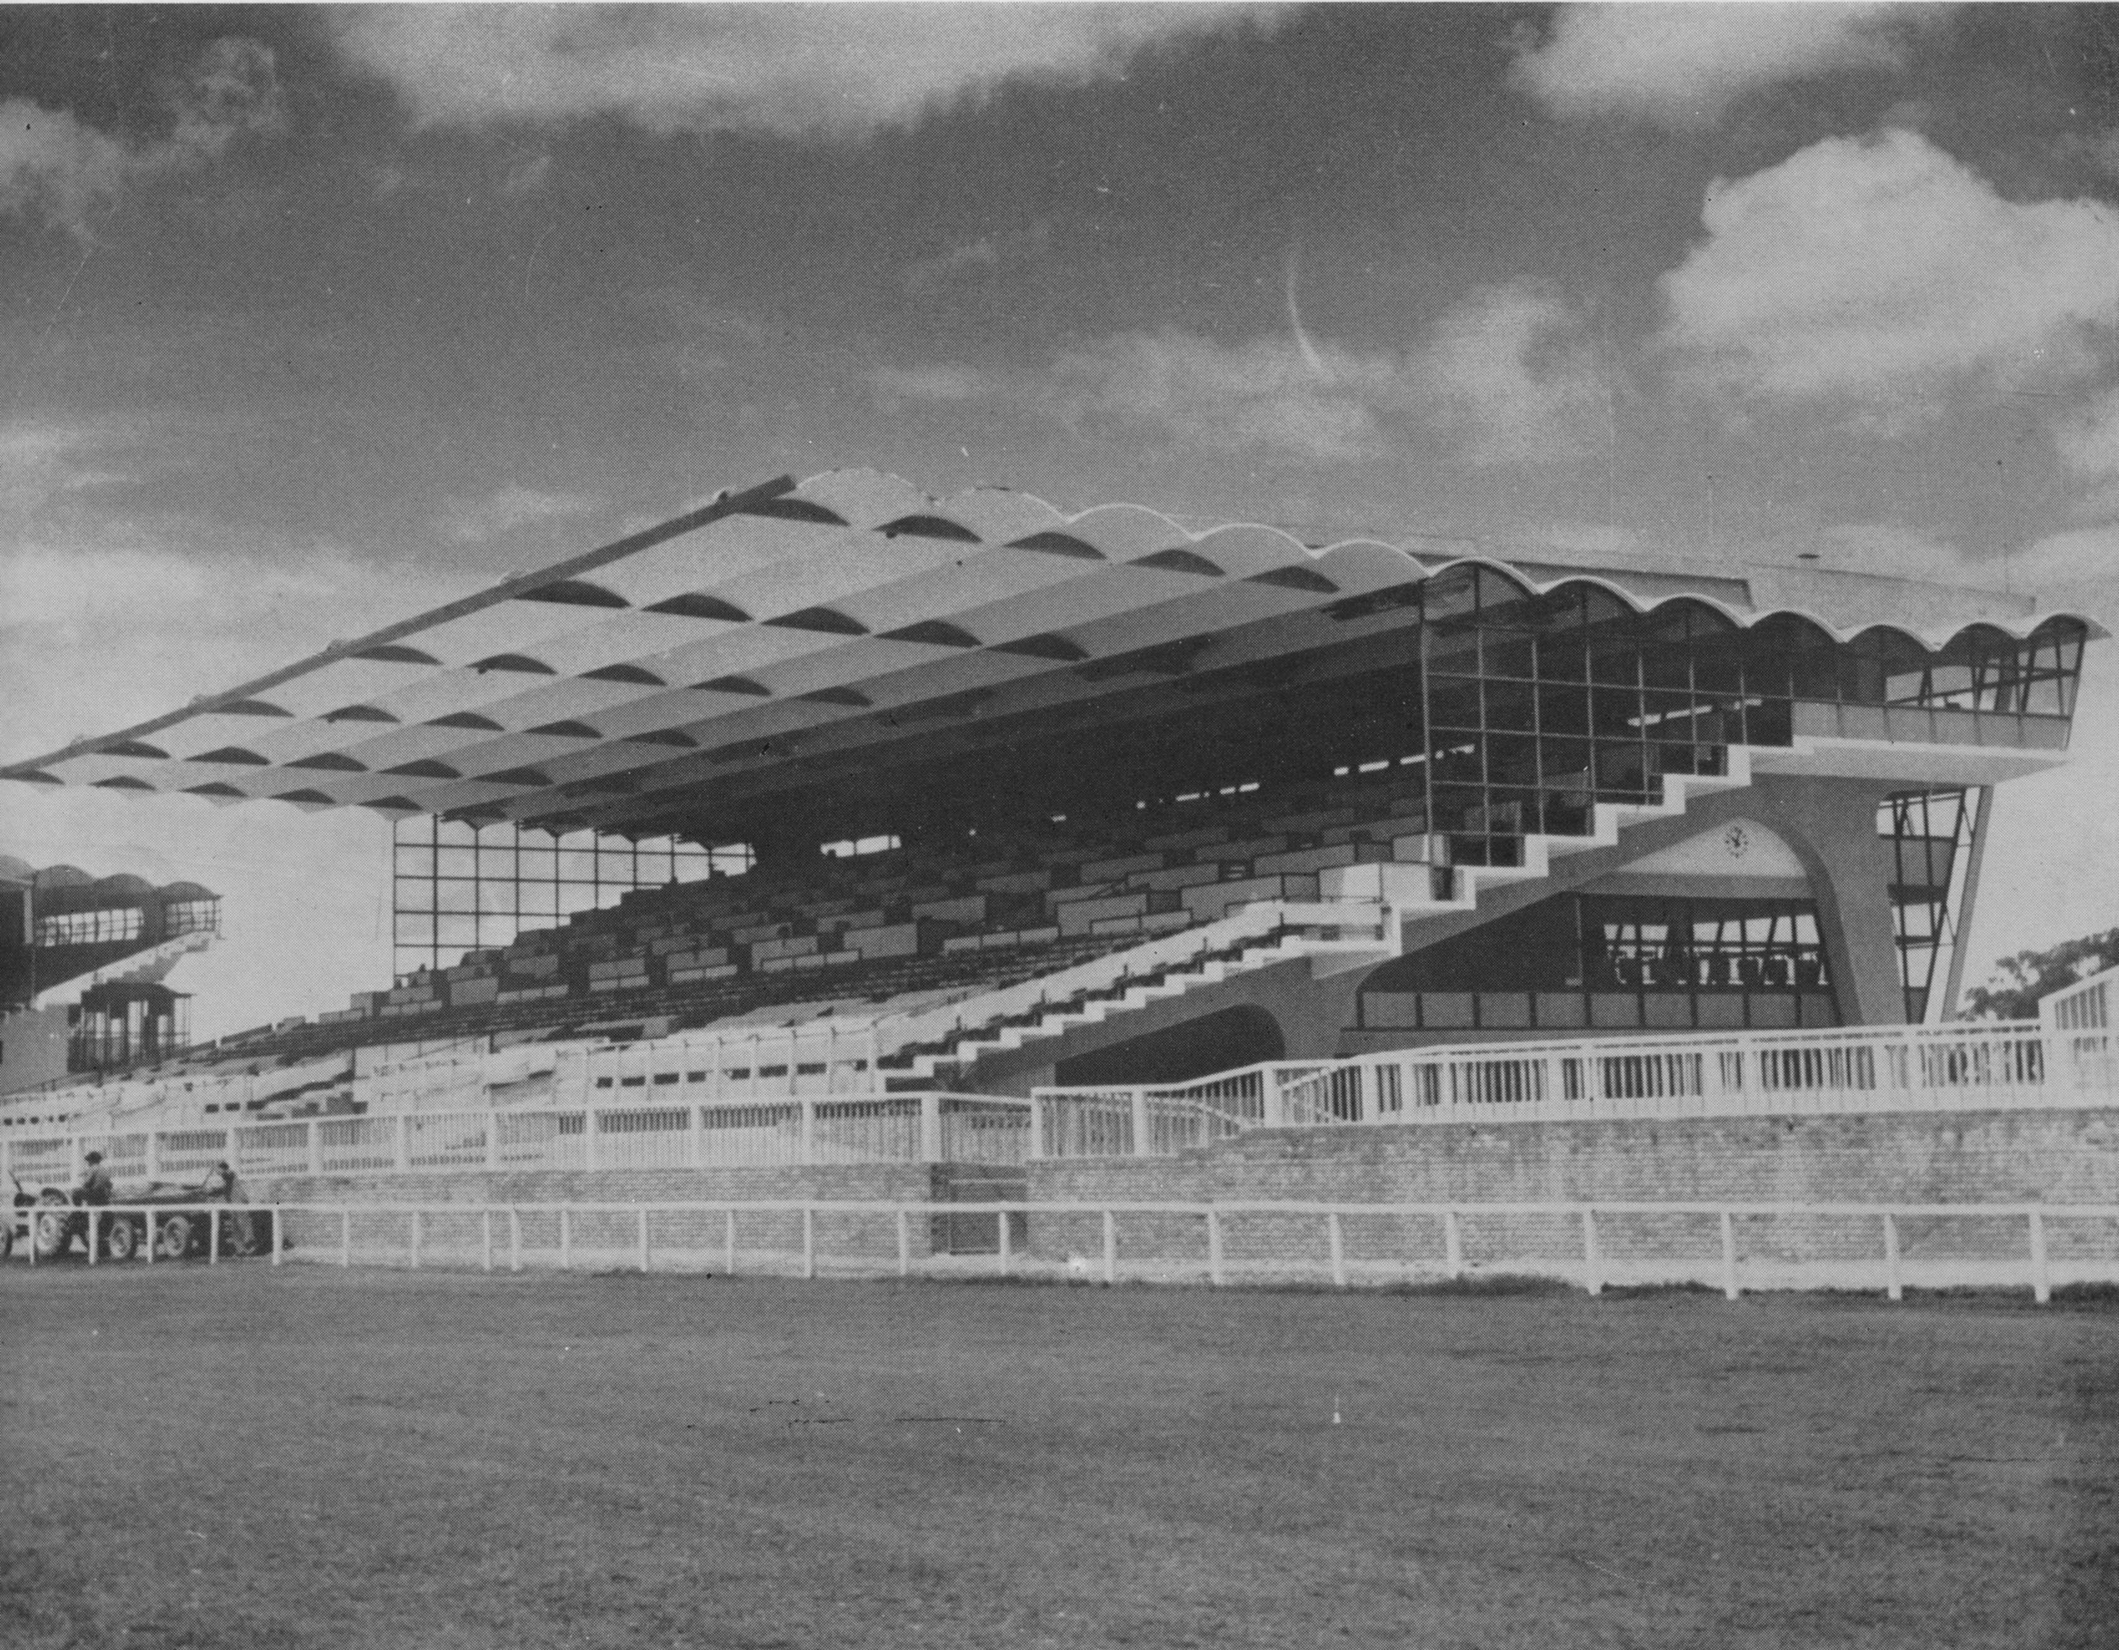

1956-59 Olympic Villa in Cartagena, with Carlos Hernández, Germán Samper, Eduardo Pombo, and the firms Ricaurte-Carrizosa-Prieto and Obregón-Valenzuela.

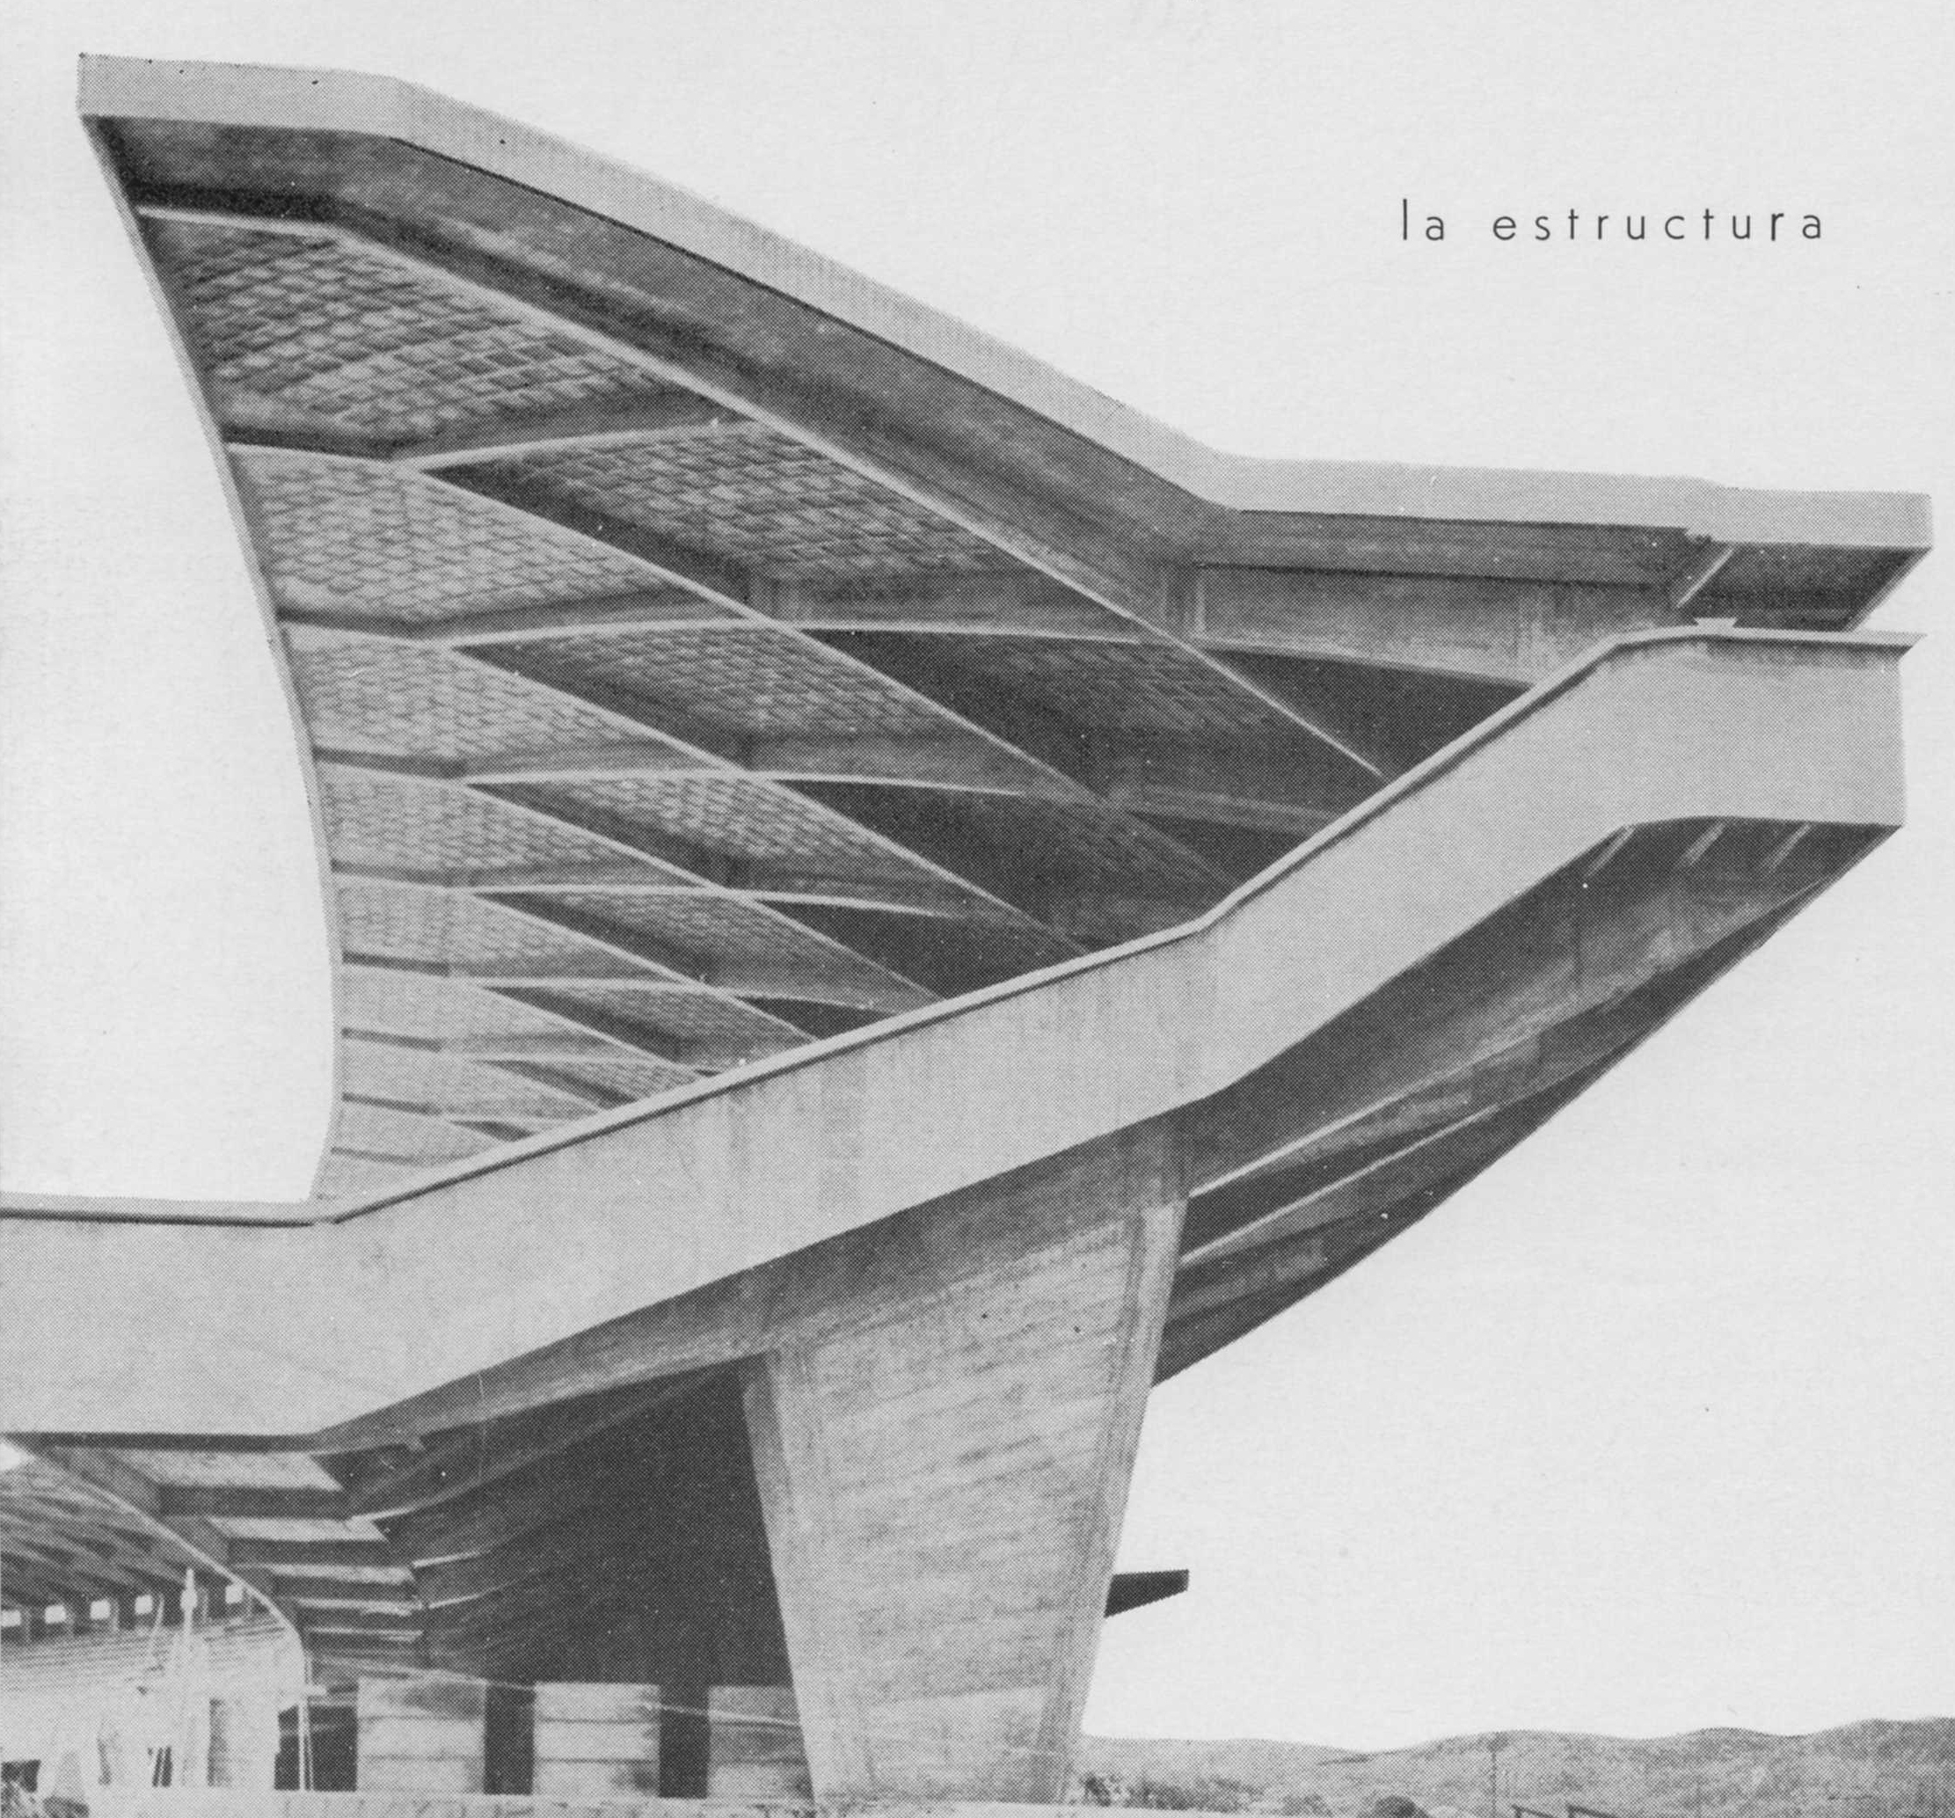

## Copyright material

Name of your entry in the Encyclopedia: Guillermo González Zuleta

Material you want to use: Gimnasio Moderno school’s chapel, Techo hippodrome, Olympic Villa in Cartagena,

Purpose of inclusion: *example*

Link to Material (if online):

Bibliographic details (if appropriate):  Martínez, C., & Burbano, E. (1963). *Arquitectura en Colombia*. Bogotá: Proa.

Copyright holder: Proa journal

Any other useful information: Lorenzo Fonseca lfonmar@gmail.com

Name of your entry in the Encyclopedia: Guillermo González Zuleta

Material you want to use: Baseball stadium in Cartagena, Bus station

Purpose of inclusion: *example*

Link to Material (if online):

Bibliographic details (if appropriate):  Arango, J., & Martínez, C., (1951). *Arquitectura en Colombia: arquitectura colonial 1538-1810, arquitectura contemporánea en cinco años 1946-1951*. Bogotá: Proa

Copyright holder: Proa journal

Any other useful information: Lorenzo Fonseca lfonmar@gmail.com

Name of your entry in the Encyclopedia: Guillermo González Zuleta

Material you want to use: Volkswagen showroom and plant in Bogotá,

Purpose of inclusion: *example*

Link to Material (if online):

Bibliographic details (if appropriate):  Proa 89 May 1955

Copyright holder: Proa journal

Any other useful information: Lorenzo Fonseca lfonmar@gmail.com

Name of your entry in the Encyclopedia: Guillermo González Zuleta

Material you want to use: Market at Girardot

Purpose of inclusion: *example*

Link to Material (if online):

Bibliographic details (if appropriate):

Copyright holder: El Espectador

Any other useful information: [www.elespectador.com](http://www.elespectador.com) servicioalcliente@elespectador.com

1. Academia de Historia de Cundinamarca, s.d.
2. Jaramillo Jiménez.
3. Arango & Martínez, 1951.
4. Vargas Caicedo, 2009.